Easy Porridge Recipe

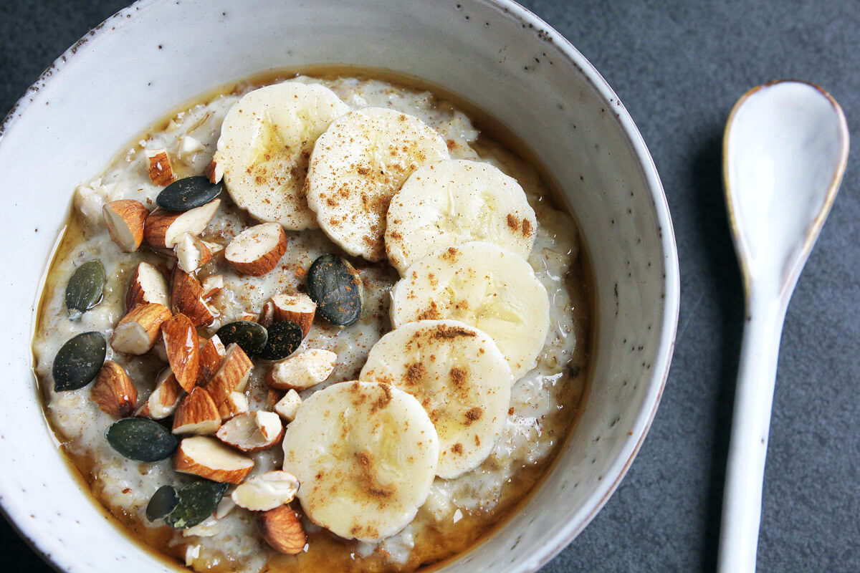

https://cheapandcheerfulcooking.com/wp-content/uploads/2020/02/porridge-basic-recipe-1.jpg photo

Ingredients:
- 1 cup rolled oats
- 2 cups milk (or water for a dairy-free option
- 1-2 tablespoons honey or maple syrup
- 1/2 teaspoon cinnamon (optional)
- Fresh fruit (such as bananas, berries, or apples)
- Nuts or seeds (optional)
- A pinch of salt

Steps:
- Gather Your Ingredients
  - Measure out all the ingredients and have them ready.
- Heat the Milk or Water
  - Pour the 2 cups of milk (or water) into a medium-sized pot.
  - With a parent’s help, heat the milk over medium heat until it starts to simmer. Make sure not to let it boil.
- Add the Oats
  - Stir in the 1 cup of rolled oats.
  - Add a pinch of salt and the 1/2 teaspoon of cinnamon if you’re using it.
- Cook the Porridge
  - Reduce the heat to low and let the oats cook, stirring occasionally.
  - Cook for about 5-7 minutes, or until the porridge has thickened to your liking.
- Sweeten the Porridge
  - Once the porridge is cooked, remove the pot from the heat.
  - Stir in 1-2 tablespoons of honey or maple syrup to sweeten.
- Add Toppings
  - Pour the porridge into bowls.
  - Add your favorite toppings, such as sliced bananas, berries, chopped apples, nuts, or seeds.
- Enjoy Your Porridge
  - Let the porridge cool slightly before eating.
  - Enjoy your warm and yummy porridge!

Tips:
- Be careful when working with the stove and hot ingredients. Always have a parent help.
- You can customize your porridge with different fruits and toppings.
- If you like your porridge creamier, add a bit more milk.
Happy cooking!

