### **Winnie The Pooh Map Activity! 🗺️✨**

[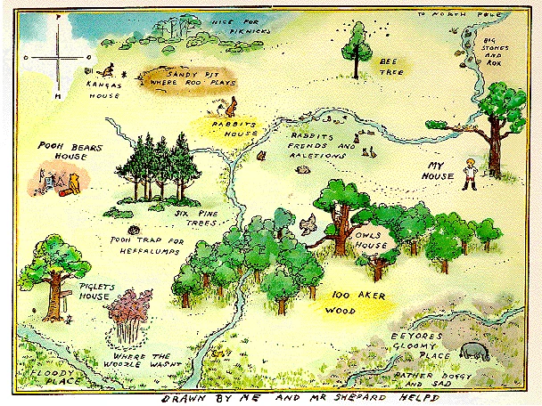](https://pooh.fandom.com/wiki/Hundred_Acre_Wood)

### **Design Your Bedroom Map! 🗺️✨**

Look above at the map of The 100 Acre Wood!!

In this activity we want to encourage you to think creatively and use spatial awareness skills by drawing a map of your bedroom. We hope you’ll have fun designing and labeling your very own personal space.

### **Materials Needed**

* Blank paper (graph paper works well but is optional)
* Pencils, markers, or crayons
* A ruler (optional)

### **Step-by-Step Instructions**

1. **Introduction: What Is a Map?**
   * A map is like a bird's-eye view of a space.
   * See the Winnie the Pooh map above? We want you to use that as inspiration to create!
2. **Imagine Flying Over Your Bedroom**
   * Pretend you’re flying above your bedroom, looking straight down. What do you see?
3. **Start with the Outline**
   * On the paper, draw a big rectangle or square to represent the shape of your bedroom.
   * Use a ruler to keep lines straight if you want.
4. **Add Big Items First**
   * Think about the big furniture in the room, like the bed, dresser, or desk.
   * Draw these as simple shapes (e.g., a rectangle for the bed, a square for the dresser).
5. **Add Details**
   * Add smaller items like rugs, toys, bookshelves, or windows.
   * Use symbols or drawings to represent objects (e.g., a small circle for a lamp).
6. **Label Everything**
   * Write the names of each item or area directly on the map.
   * For example: "Bed," "Closet," "Toy Bin."
7. **Decorate the Map**
   * Now, color in your map, add patterns, or you can even include fun extras decorations like stars to mark "special spots" in your room.
8. **Optional: Add a Key**See below to create a map key in one corner.
   * Example:
     + ⭐ = Favorite Spot
     + 🔲 = Toy Box
     + 🌞 = Window
9. **Share Your Map!**
   * Now, go show your maps to others and explain the layout of your bedroom.
   * You can even compare maps with siblings or friends to see how different your rooms are!

### **Extension Ideas**

* **Treasure Map**: Hide a small object in the room and mark its location on the map with an "X."
* **Dream Bedroom**: Instead of drawing your real bedroom, you can design your dream bedroom with fun features like slides or candy dispensers.

We can’t wait to see your creations!🌈